**Working with express**

Install express

npm install express

Check version of express: npm list express

Let’s create first app using express

const express= require('express');

const app= express();

app.get('/',(req,res)=>{

    res.send('Hello World');

})

app.get('/login',(req,res)=>{

    res.send('This is my login page');

})

app.listen(3000,()=>{

    console.log('App started on port number 3000');

})

Load files statically

Use express.static()

Create one folder named common and create home.html file inside that

Home.html

<h1>Welcome to the world of APIs</h1>

Create static.js file

const express= require('express');

const path = require('path');

const app= express();

app.use(express.static(path.join(__dirname,'common')))

app.get('/',(req,res)=>{

    res.send("<a href='home.html'>Home</a>");

})

app.listen(3000,()=>{

    console.log('App started on port number 3000');

})

Run app using node static.js

Check localhost:3000/

We can directly access all static files with this url

Localhost:3000/filename

**Jade Template**

Install – npm install –g jade

Check version: jade –V

Check more details: jade –help

Create jade template inside views folder

Sample.jade

doctype html

html

  head

    title my jade template

  body

    h1 this is produced by Jade Engine

    p  some data

load template in server

var express= require('express');

var app= express();

app.set('view engine','jade')

app.get('/',(req,res)=>{

    res.render('sample');

})

app.listen(3000,()=>{

    console.log('server is running on port number 3000')

})

Execute node filename.js

Express Generator

To generate a full express application

Install: npm install –g express-generator

To create app – express app-name

If you want to give some with app

Express –view=jade app-name

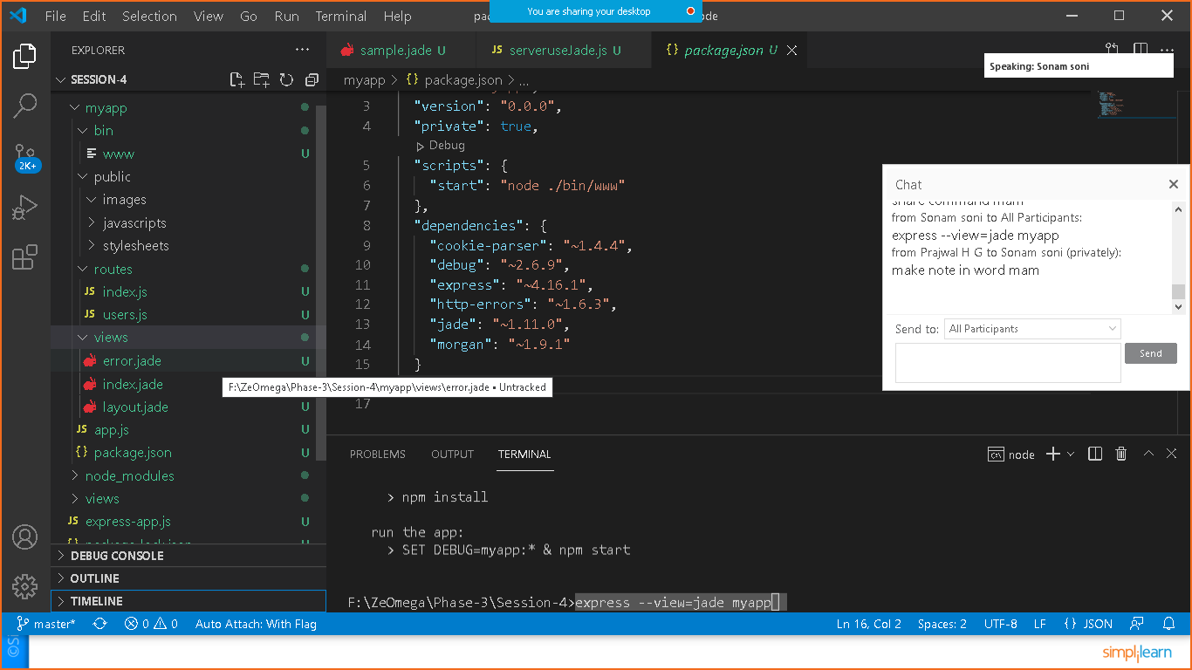

Understood json data handling with different function.

Go through with the eBook and execute the example

CRUD APP using express, REST API

Create folder CRUD-APP

Cd CRUD-APP

Execute – npm init

Generate package.json file

Install express: npm install express

Check package.json dependencies to get confirmation of express installation.

Create app.js file

const express= require('express');

const server= express();

server.get("",(req,res)=>{

    res.end('Hello from express');

})

server.listen(3000,()=>{

    console.log('server listening on port no 3000');

})

Edit package.json file add “script”:”node app.js”

{

  "name": "crud-app",

  "version": "1.0.0",

  "description": "",

  "main": "index.js",

  "scripts": {

    "start": "node app.js",

    "test": "echo \"Error: no test specified\" && exit 1"

  },

  "author": "",

  "license": "ISC",

  "dependencies": {

    "express": "^4.17.2"

  }

}

Execute npm start to run file.

Create model – product.js

//model created

module.exports=class Product{

    constructor(name,price)

    {

        this.name=name;

        this.price=price;

    }

}

Create controller.js

const express= require('express');

const Product = require('./product');

const router= express.Router();

//products: Product[10]=[];

router.get("",(req,res)=>{

    res.status(200).send("Welcome user");

});

router.post("");

router.put("");

router.delete("");

module.exports= router;

add controller to handle specific request to app.js file

check the code.

const express= require('express');

const productController= require('./controller')

const server= express();

server.get("",(req,res)=>{

    res.end('Hello from express');

})

server.use("/api/product",productController);

server.listen(3000,()=>{

    console.log('server listening on port no 3000');

})